**Flutter Stateful and Stateless Widgets**

When it comes to Flutter, the main starts are the widgets, in Flutter there are mainly two types of widgets; stateful and stateless widgets. Today i am going to explain those terms.

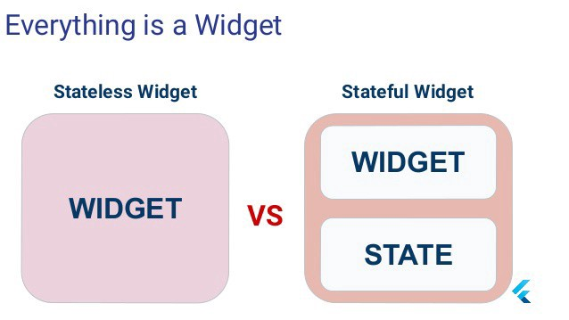

**What is state ?**

A state is the property of the widget that can change after the built as long as the widget is there. For example, a checkbox has a state and when we check it or uncheck it, the state also changes.

**Stateless Widgets**

So we have covered what a state is but there are also stateless widgets in flutter. After the app is built the states of those widgets can’t be changed. For example icon or text widgets.

**Example of Stateless Widgets**

import 'package:flutter/material.dart';class Stateless_ex extends StatelessWidget {  
 const Stateless_ex({Key key}) : super(key: key); @override  
 Widget build(BuildContext context) {  
 return MaterialApp(  
 home: Scaffold(  
 appBar: AppBar(  
 title: Text("Stateless Widget"),  
 ),  
 body: Center(  
 child: Icon(  
 Icons.add_circle_outline_sharp,  
 ),  
 ),  
 ),  
 );  
 }  
}

**Example of Stateless Widgets**

import 'package:flutter/material.dart';class Stateless_ex extends StatelessWidget {  
 const Stateless_ex({Key key}) : super(key: key); @override  
 Widget build(BuildContext context) {  
 return MaterialApp(  
 home: Scaffold(  
 appBar: AppBar(  
 title: Text("Stateless Widget"),  
 ),  
 body: Center(  
 child: Icon(  
 Icons.add_circle_outline_sharp,  
 ),  
 ),  
 ),  
 );  
 }  
}

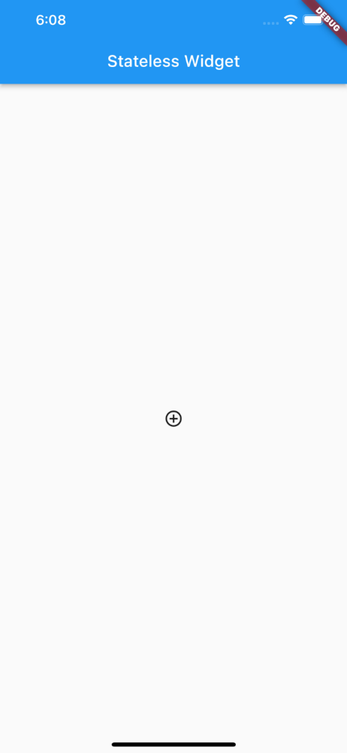

I have created an app bar and it has a text widget, there is also an icon widget, and i didn’t add any state changer so they will remain the same after the built.

**Stateful Widgets**

The widgets that their state can change after the built and can also change multiple times as long as the widget is there.

**Example of Stateful Widgets**

Before we see an example of stateful widgets let’s see what set State is;

**setState Method**

When we change a state of a widget, we call setState method to see the changes on use.

Now let’s see an example;

import 'package:flutter/material.dart';  
  
class Stfull_ex extends StatefulWidget {  
 const Stfull_ex({Key key}) : super(key: key);  
  
 @override  
 _Stfull_exState createState() => _Stfull_exState();  
}  
  
class _Stfull_exState extends State<Stfull_ex> {  
  
 bool _isPressed=false;  
  
 @override  
 Widget build(BuildContext context) {  
 return Scaffold(  
 body: Center(  
 child: FlatButton(  
 color: _isPressed ? Colors.amber:Colors.black,  
 onPressed: (){  
 setState(() {  
 _isPressed=!_isPressed;  
 });  
 },  
 ),  
 ),  
 ); }  
}

In this code i declared a boolean variable to control the color of the button in state changes, i created a button in the center of the app and when pressed the state of the variable changes thus the color of the button changes, i also used setState method to see the state change immediately.

Here is the output;



That was all from me today, thanks for reading hope you enjoyed it ;)

https://medium.com/yaz%C4%B1l%C4%B1m-ve-bili%C5%9Fim-kul%C3%BCb%C3%BC/flutter-stateful-and-stateless-widgets-94dbedd51635

https://api.flutter.dev/flutter/widgets/StatefulWidget-class.html